

**Services**

Extended Access (Out of Hours) Services

**Social Prescribing**



Morley PCN offers Social prescribing appointments.

For patients who require non-clinical intervention to support and manage their health and wellbeing.

This includes referral to community groups and services, referral to welfare advice and referral to social care services.

**Healthy Minds Service** 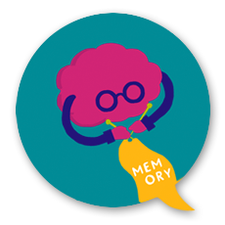

Morley PCN extended access service offers a virtual mental health support service for patients aged 18 and over who are feeling low, irritable, anxious, or stressed, are experiencing poor sleep or concentration, or have had a recent bereavement and would like help with emotional wellbeing.

**PCN Pharmacy Team**



* The PCN Pharmacy Team are supporting practices and patients with structured medication reviews, medication clinics and medication queries.
* for a wound review.

**Nurse & HCA Appointments**



Morley PCN extended access service offers Nurse and HCA out of hours on weekends (face to face and telephone) from Windsor House Surgery, Morley. Additional GP appointments are also available weekdays again from Windsor House

**GP Appointments**



Morley PCN extended access service offers out of hours GP appointments. Both face to face and telephone appointments are offered. These run from Windsor House Surgery, Morley. 

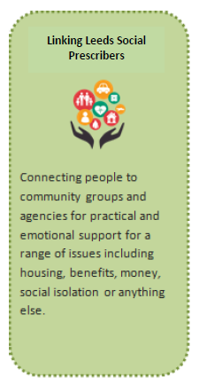

**Health and wellbeing Coach (HWBC)** 

For patients who wish to make long lasting lifestyle change, such as changes to weight, diet, smoking cessation or having an active lifestyle. Conditions include high blood pressure, pre-diabetes and type 2 diabetes, high ​cholesterol, and overweight/obesity.

**Physio first**

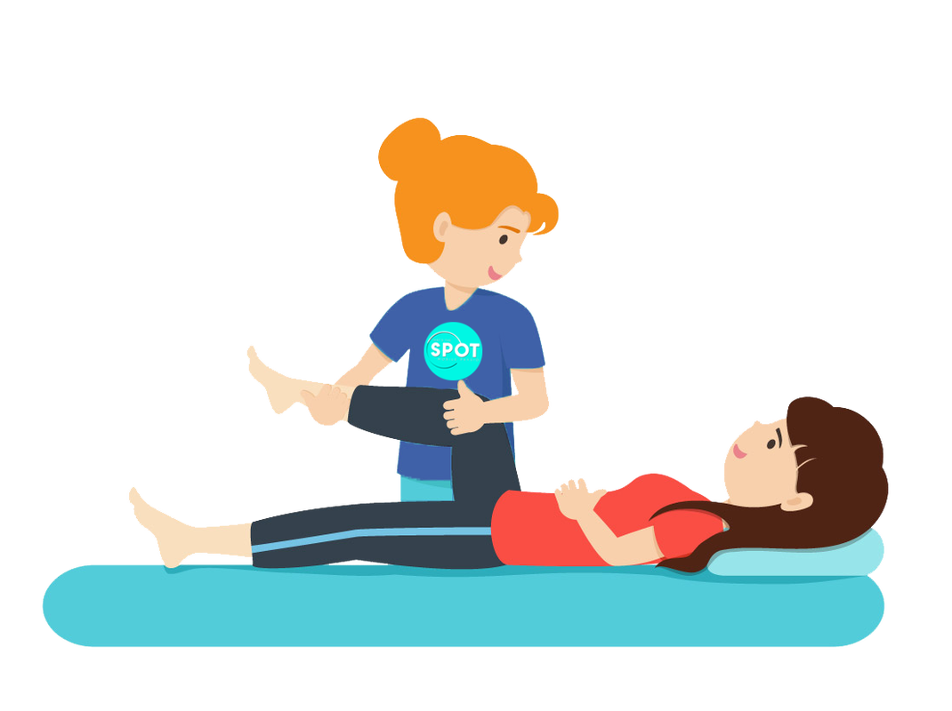

For patients who are experiencing problems such as back pain, neck pain, shoulder pain and from sports injuries.

**Leeds Mental Wellbeing Service (LMWS)**



Age 17+. Providing support and psychological therapies GAD, panic, OCD, mild bulimia and PTSD. Includes 1:1, group, classes and online support options. Online self-therapy and classes for depression, sleep, anxiety etc.

**Occupational Therapy** 

Morley PCN offers OT appointments to assess individuals who experience difficulties with activities of daily living. E.G bathing, mobility outdoor access. Supporting with the frailty pathway. Reduce falls and Hospital admission. And can provide, (subject to local council criteria) outdoor aids such as rails and ramps.Can provide equipment to aid daily task such as walking aids.

I can also administer cognitive assessments from basic 6cit test to more complex Neuro assessments